**‘AccessBank DBA Internship Program’**

**Project 4: Restoring a database**

One of the most important jobs of the DBA is the restoration of a database if it becomes corrupt, or needs to be moved to another server, or developers ask you to restore a recent backup into dev environment. As such, one of developer indicated that the database in test server called Finance became outdated and needs to be refreshed for the 24.07.20 15:00 PM date exclusively so that you have the most current data available (50 records).

You need to find all the types of backups available for the Finance, move them into your default backup folder and restore the database.

NOTE: Your backup plan is:

**Backup plan:**

**FULL backup for HR and Finance databases everyday at 04:00 AM and LOG backups every hour from 12:00 PM to 12:00 AM.**

NOTE 2:

--delete the old database - right click, chose delete, ok

NOTE 3:

--RESTORE THE NEW DATABASE. (HOW MANY RECORDS ARE THERE? IT SHOULD BE 50)

**I have created users and transactions tables in FinanceDB and inserted 15 rows of data into users and 30 rows of data (for each user 2 transactions) into transactions by using T-SQL statements:**

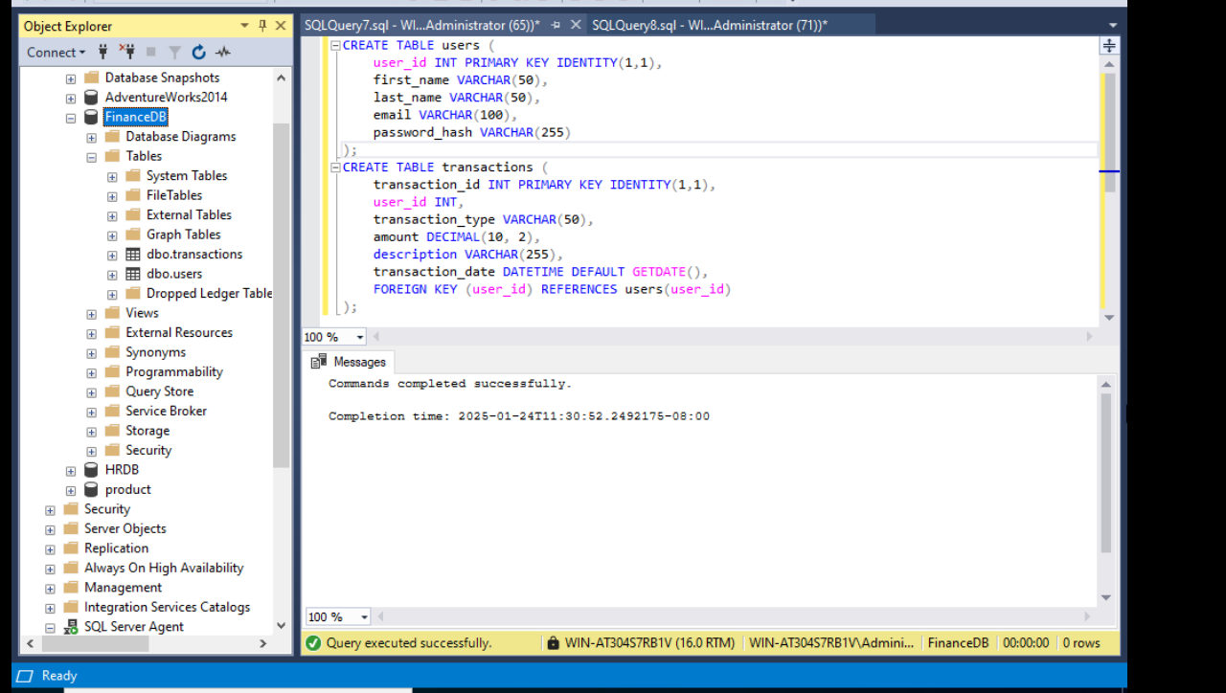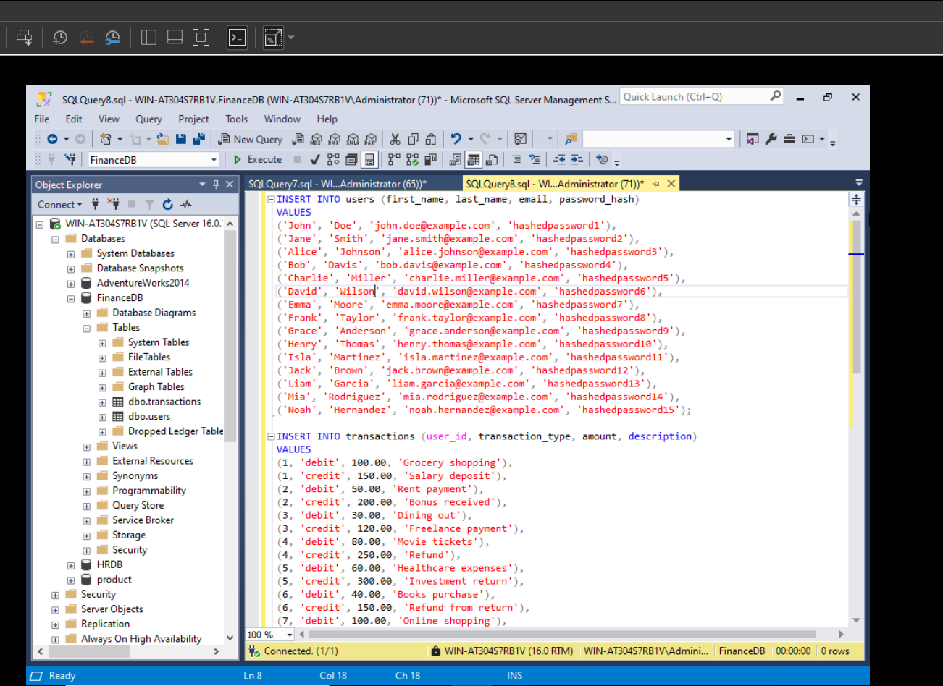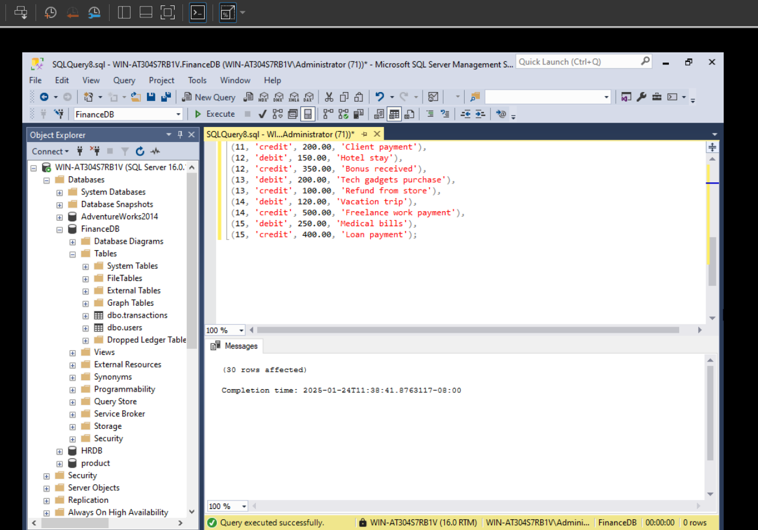

**After inserting I deleted FinanceDB database:**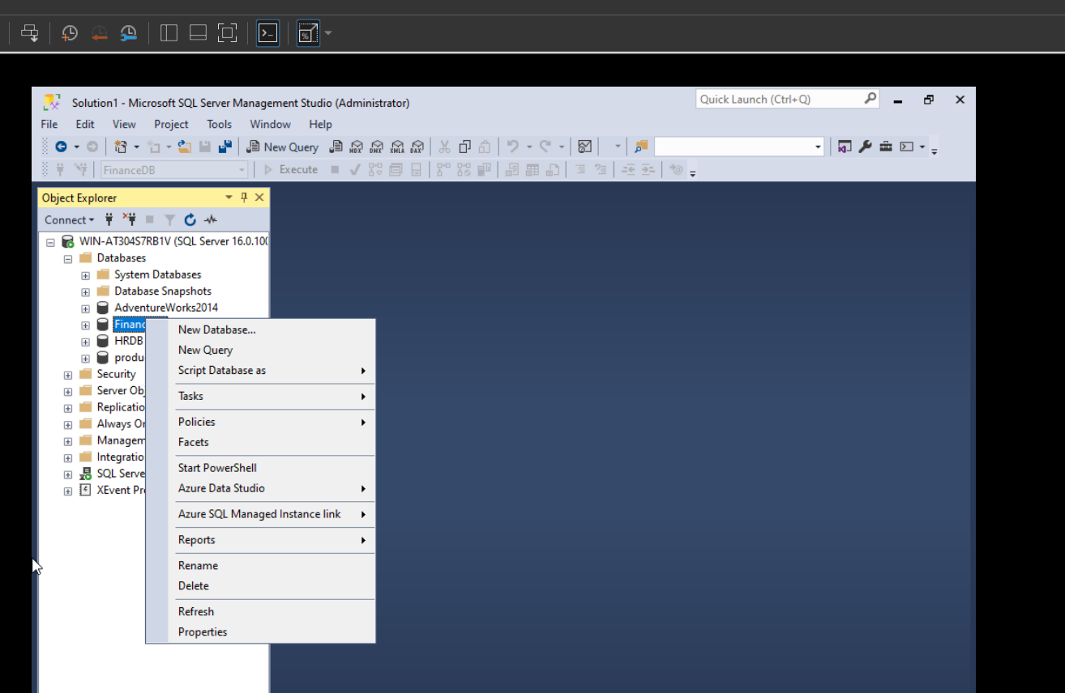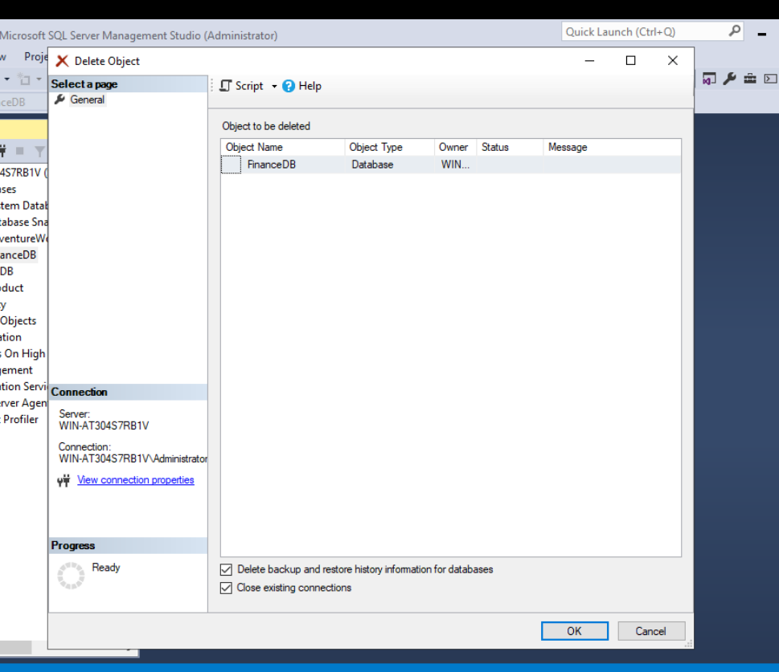

**After successfully deleting I will choose Databases and right click, then choose Restore Database… :**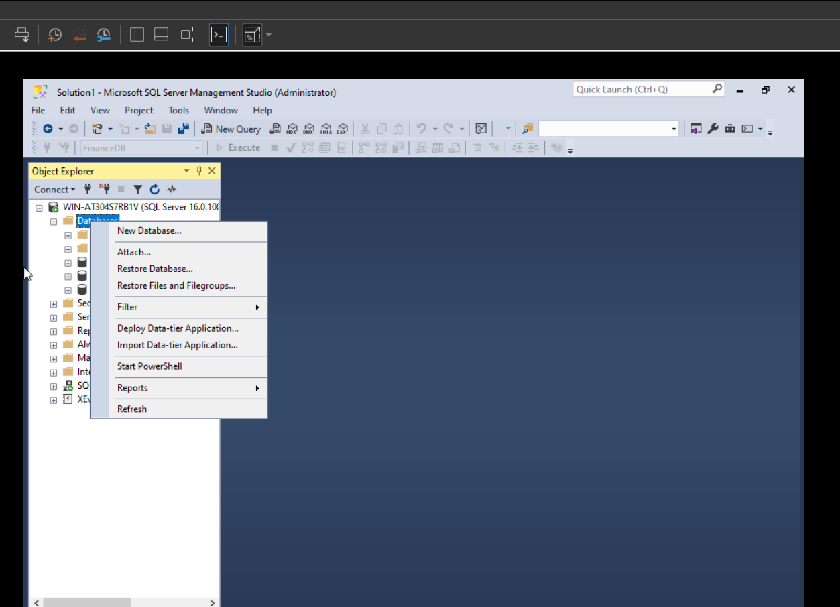

**Now I selected files for recovery and these files are the files that SQL Server Agent did its Jobs and run FULL and TLOG backup subplans, after selecting choose OK and that’s it FinanceDB is restored:**

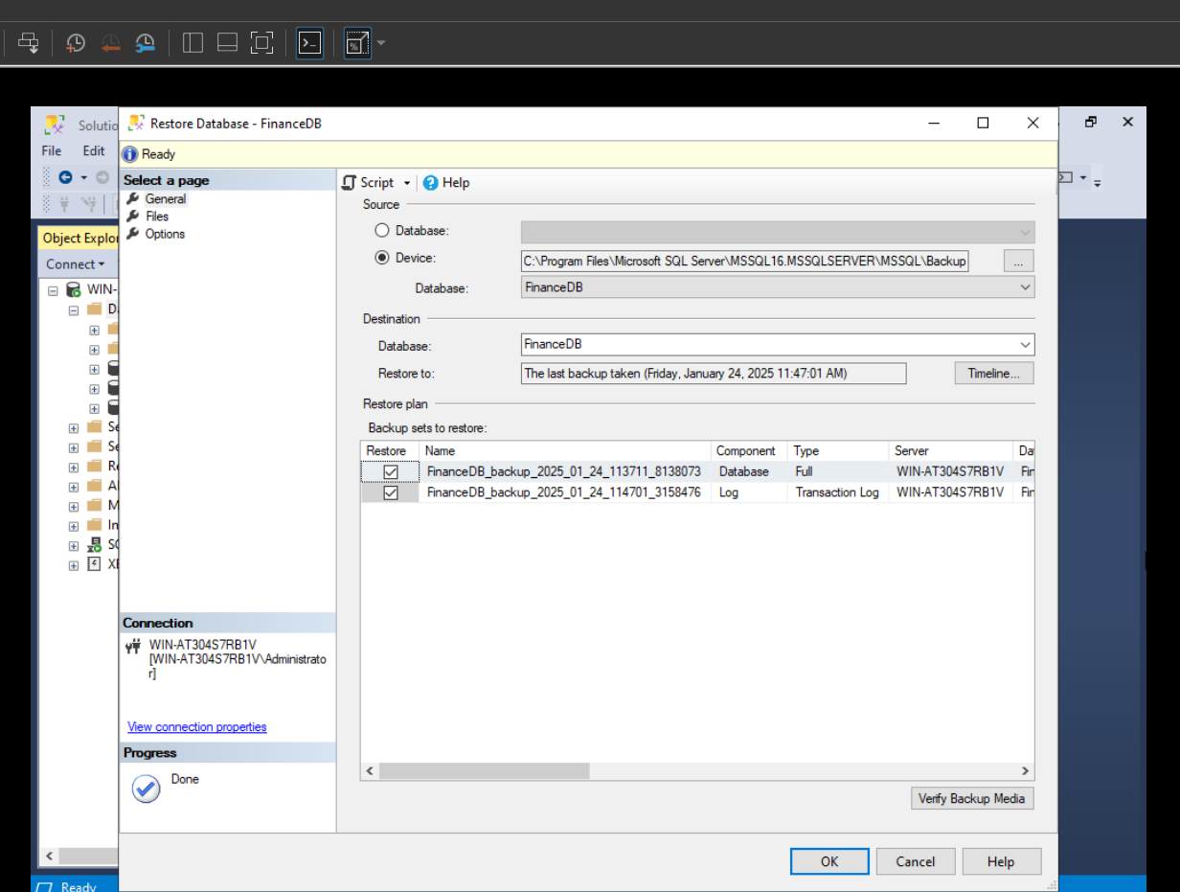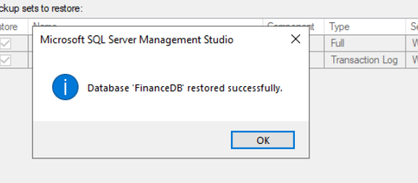

**Now let’s verify all of these 45 rows is restored successfully or not**: